LUMINOUS INTENSITY SENSOR
1. Product Overview
WIN-SN-LUX-W is a versatile data acquisition device designed for real-time monitoring in industrial applications, especially ducts. It supports a wide range of external sensors with UART interface, providing flexibility for various measurements. Offering reliable communication and long-range data transfer over several meters, making it ideal for large-scale installations.
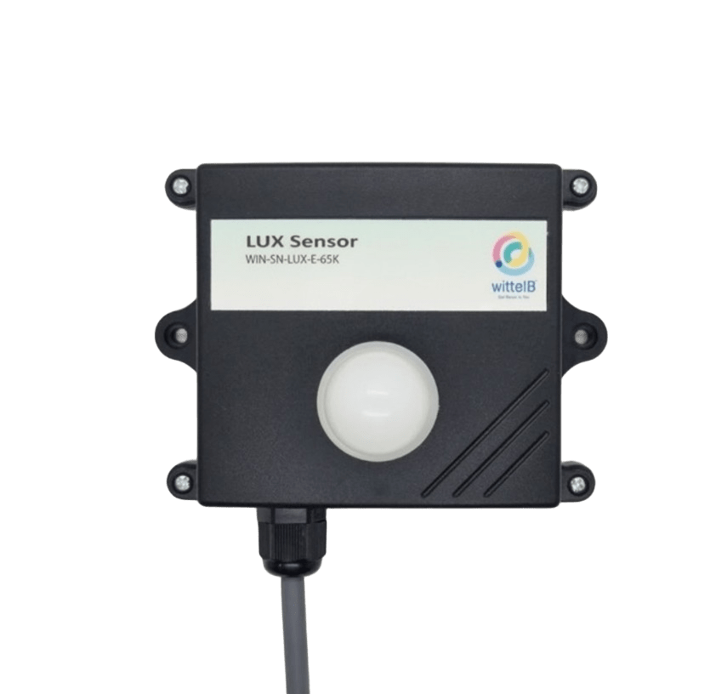
Its robust design makes it suitable for installations in HVAC systems, environmental monitoring, and process control. With configurable data sampling rates, multi-sensor compatibility, and easy configuration, WIN-SN-LUX-W ensures accurate LUX data acquisition and reliable performance in demanding industrial environments, making it an excellent choice for industrial and IOT applications
Ex: - Product Image
• Luminance to Digital Converter ranging 1 LUX to 65000/200000 LUX.
• Superior sensor performance.
• Operating range -20°C to 60°C and 0% to 70% RH for humidity
• Fully calibrated and processed digital.
• Wide Input voltage options 12-24V DC
• Excellent long-term stability
 | Measuring Parameter | Measuring Range | Operating Temperature
☐ | Luminous intensity | 1-65000 LUX | -20°C ~ 60°C.
☐ | Luminous intensity | 1-200000 LUX | -20°C ~ 60°C.

2. Sensor Specifications
- Wide temperature range: −40 °C to +125 °C
- Full humidity range: 0 % to 100 % RH
- Power supply DC: 12-24V@1A.
- Product dimension: 85*85*40 mm.

- Certifications:

3. Power Supply Connection
DC Connection
- Use 12-24V@ 1A, Power supply.
- Don’t make loose connection.

5. Device Configuration Process
- Connect the Device
  - Connect 12v-1A DC adaptor to power the board
  - Connect the Wi-Fi SSID: WittelB-SN-LUX Pass:123456789
  - Enter the IP 192.168.4.1 in web browser
  - Refer image 1 for Wi-Fi WittelB-SN-LUX
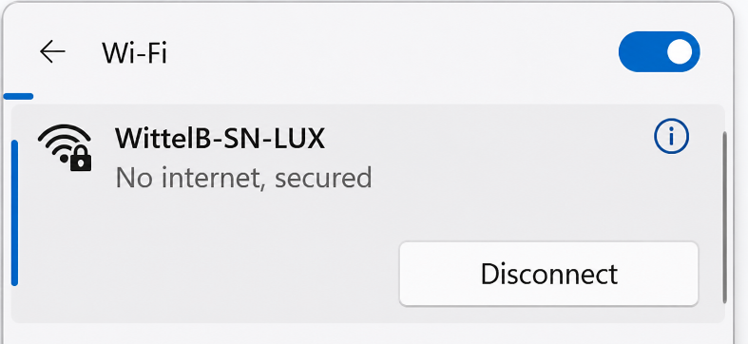

Image: 1

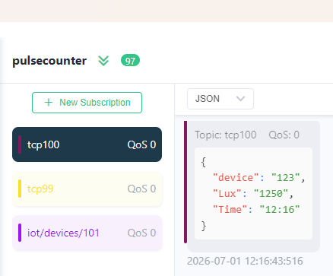
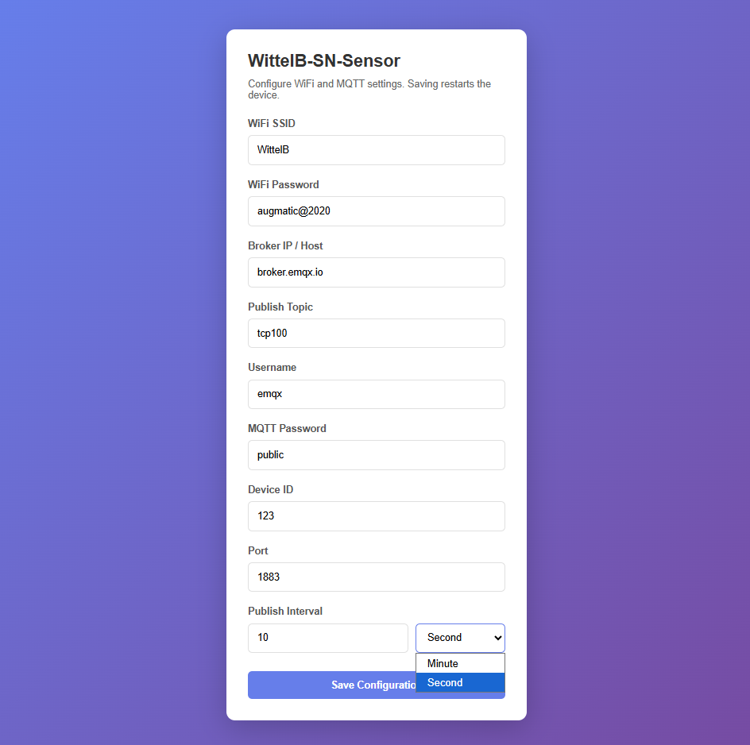
Image: 2 Image: 3
- Enter IP 192.168.4.1 in web browser then you will see the Web UI.
- Enter the local WiFi credentials as shown in above image2 so the device can connect to that WiFi network. Using this connection, it will send the sensor data to the cloud.
- Then enter the required MQTT Credentials and make sure the Credentials should be correct.
- As shown in Image 2, you can select the publish interval in either minutes or seconds. MQTT data will be published according to the selected interval.
- Enter the MQTT credentials to transmit the sensor data to the cloud.
- Image 3 shows the sensor data at cloud for the selected topic.
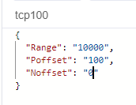

Image: 4
- For Subscribed topic through MQTT where user can set the range, Positive offset and Negative offset as shown in image4.

Contact Information
Augmatic Technologies Pvt. Ltd.,
Plot no 6, Shah Industrial Estate II,
Kotambi,
Vadodara – 391510.
Email – Sales@wittelb.com
Support: support@wittelb.raiseaticket.com / +91 94038 92805

